5420 Assignment-4-Team-19

Date: November 26, 2020

Team members names with Student id:

Anannya Chatterjee (#11463884)

Tejasvi Meka (#11447880)

Riddhi Mukund Shinde (#11455375)

1. **I have created a database named “anadb”.**

The command that is used is **“use anadb”.**

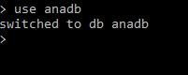

After creating the document when I issued “show dbs"

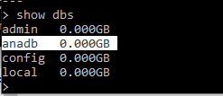

1. **I have created a collection in the database “anadb” and named it “university”.**





1. **I have created a JSON file named “Assg4data.json” and I have inserted five documents and each of these five documents have six fields.**

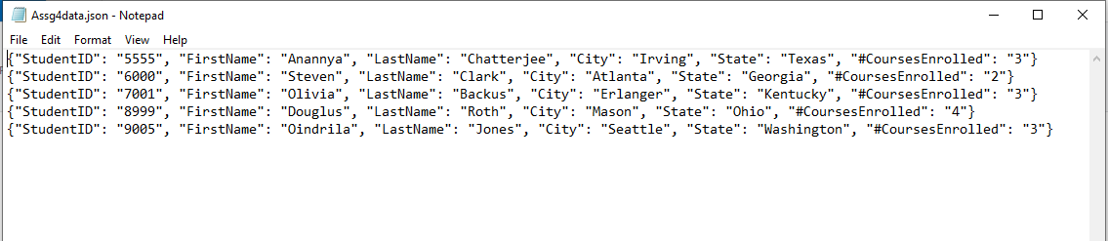

1. **Then, I have loaded the data into the collection “university”.**

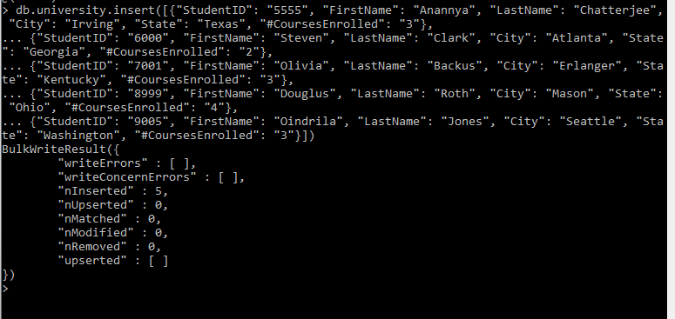

**This loading of data could also have been done by using the below utility command.**



1. **Now I am displaying the list of all my documents without the _id.**

**The command used is:**

db.university.find({},{id:0})

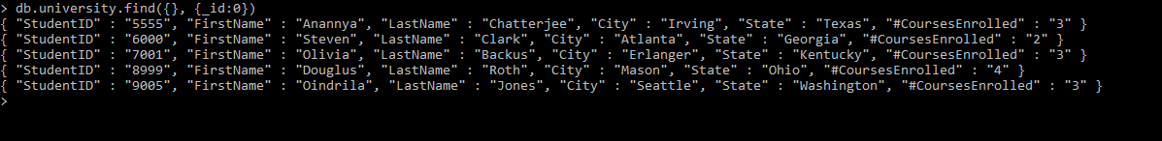

1. **I have added one additional document into the collection named university with FirstName as “Kelli”.**

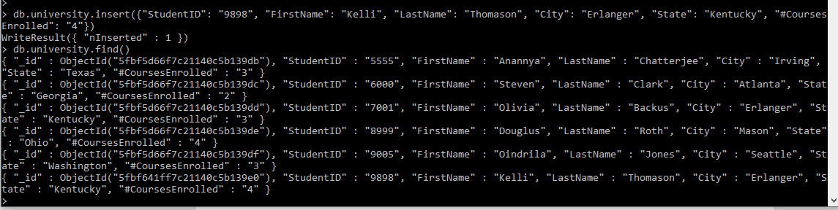

1. **I have now removed one of the documents from the university collection:**

**I have removed here the document with LastName as “Thomason”.**

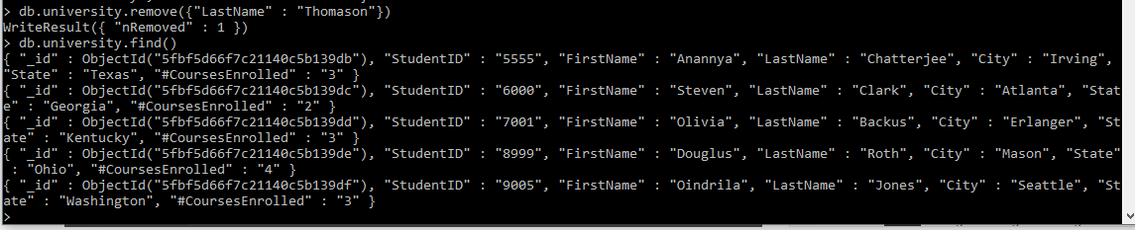

1. **I have updated two different documents. For each document, I have updated a different field.**
2. Updated ‘LastName’ of “Chatterjee” to “Mukherjee”

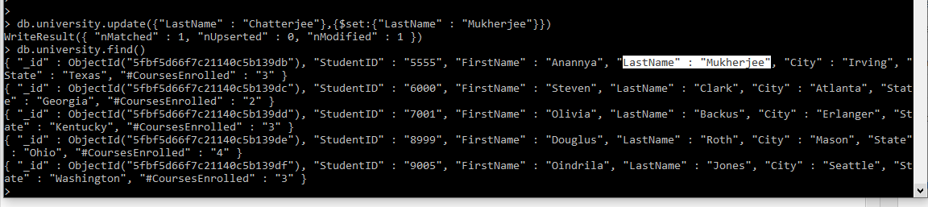

1. Updated ‘#CoursesEnrolled’ from 4 to 3 for the student named Douglus .

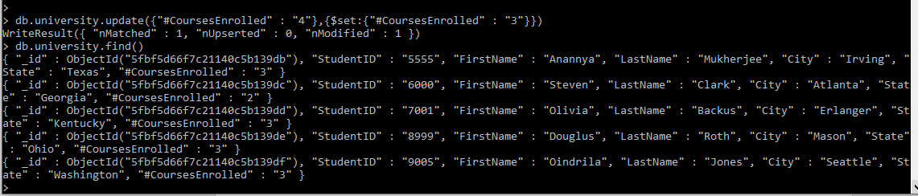

1. **Here I have showed a pretty listing of my document but after projecting every other field only.**

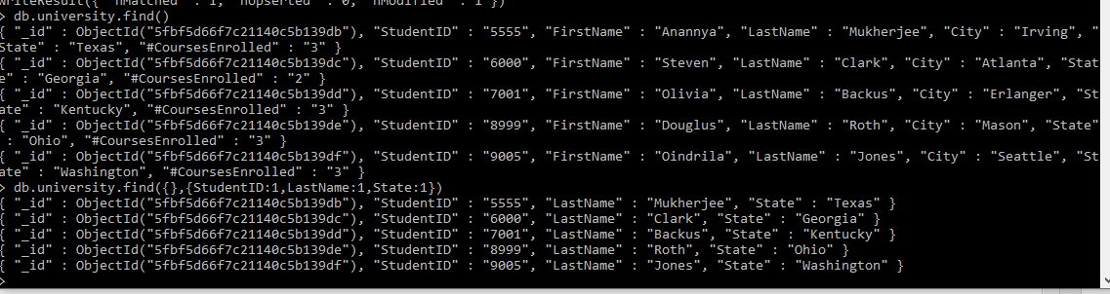

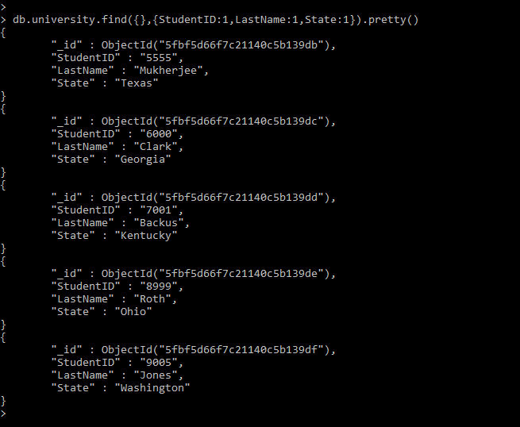

1. **Now here I am picking the “FirstName” field in the document and displaying only those documents where the “FirstName” is starting with vowel “O”.**

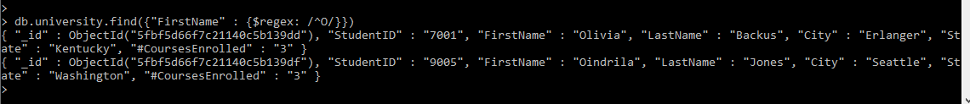

Here I conclude the Assignment #4.

Thank you.

--------------------------------XXXXXXXXXXXXXXXXXXX--------------------------------